REPORT ON MINI PROJECT

Name : Bhuvan .VS
Batch Code : TN_DA_FNB07
Contact No : 6382290752
E-mail Id : bhuvanvs2003@gmail.com
Project Title : Digital Advertising Campaign Performance
Analysis
Project Domain : Sales & E-commerce
Submission Date:10-11-2025
Mentor Name :Kumaran. M
Raw Data Link :
Clean Data Link :

Purpose of the Dataset
The purpose of this dataset is to analyse the performance of digital marketing campaigns across different platforms, devices, and keywords. It captures key advertising metrics such as clicks, impressions, cost, conversions, and revenue generated.
This dataset allows us to:
- Evaluate the effectiveness of each advertisement.
- Identify high-performing devices, dates, and keywords.
- Measure return on investment (ROI) using cost and sale amount data.
- Detect trends and patterns that help improve future marketing decisions.
- Build dashboards to visually track campaign performance.
Overall, the dataset provides a structured foundation for understanding marketing efficiency and optimizing advertising strategies.

Objectives of the Project
- To clean and preprocess the dataset by identifying and handling missing values, formatting inconsistencies, and transforming raw data into a usable structure.
- To standardize key numerical columns such as Cost and Conversions using Excel formulas (MEDIAN, IF, ISNUMBER, etc.) for accurate analysis.
- To create calculated insights including Conversion Rate, Total Sale Amount, and other performance indicators.

- To analyse marketing performance across different dimensions such as
  - Ad Date
  - Device Type
  - Keywords
  - Campaign Name
- To build an interactive Power BI dashboard that visually represents campaign metrics using charts, slicers, and KPIs.
- To understand the contribution of each category (device, keyword, date) to total campaign performance.
- To provide actionable insights that help in decision-making, such as improving ad strategies, optimizing cost, and increasing conversions.
- To document the entire process—from data cleaning to visualization—providing a clear workflow of applied techniques and tools.

Problem Statement
- The dataset contains digital marketing campaign information, including clicks, impressions, cost, conversions, sale amount, device type, and keywords.
However, the raw data includes issues such as missing values, inconsistent formatting, and unprocessed numerical fields.
Due to these data quality problems, it is difficult to assess campaign performance accurately.
- Therefore, the main problem is to clean, structure, and analyse the dataset so that meaningful insights can be generated.
This includes identifying trends, evaluating marketing effectiveness, understanding device and keyword performance, and creating an interactive dashboard for decision-making.

Tools Used

1. Microsoft Excel
- Data cleaning and preprocessing
- Handling missing values using formulas (IF, MEDIAN, ISNUMBER, etc.)
- Standardization of numerical columns
- Creating helper columns
- Validating cleaned data

2. Microsoft Power BI
- Data transformation (Power Query)
- Creating calculated measures (DAX)
- Designing interactive dashboards
- Using slicers for filtering
- Visualizing insights using charts, KPIs, and treemaps

3. PowerPoint / Word (for documentation)
- Report preparation
- Final presentation of workflow and findings

Scope of the Project
- This project covers the complete data analysis workflow—from raw data cleaning to visualization. It involves identifying inconsistencies, handling null values, transforming data types, and creating calculated fields using Excel. The scope further includes importing the cleaned dataset into Power BI, developing a dynamic dashboard, applying filters and slicers, and constructing KPIs and charts for decision-making. The project focuses on analysing campaign efficiency across devices, dates, and keywords to aid in performance optimization.

DATA CLEANING IN EXCEL
Convert Range Into Table
The entire dataset was first converted into a structured Excel Table for smooth formatting, easy filtering, and consistent formula application.
This was done by selecting the full data range and pressing Ctrl + T.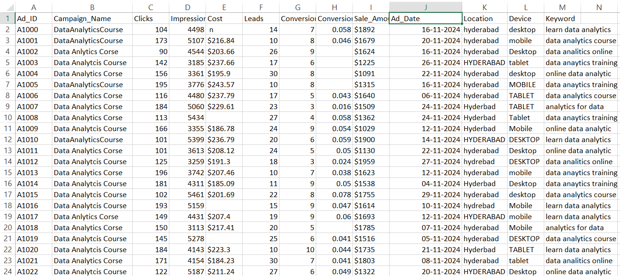Result: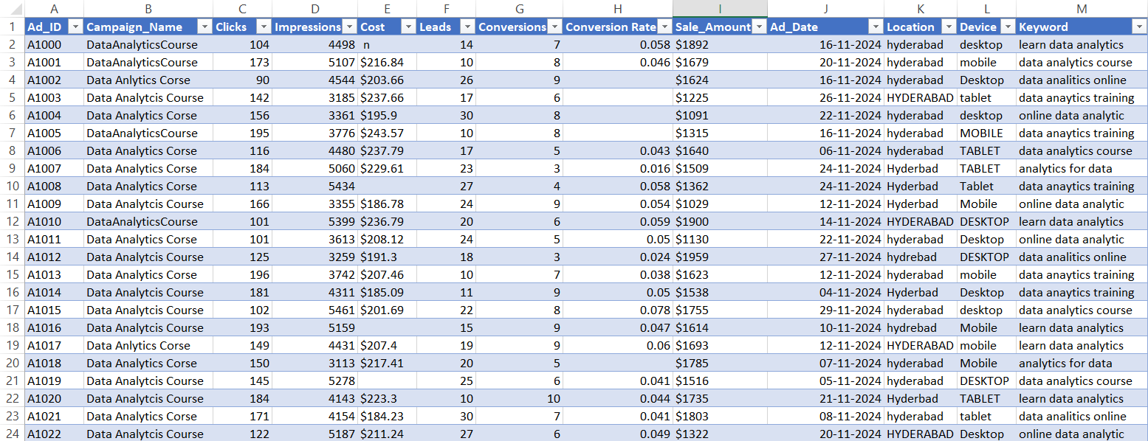

COLUMN 1 — Ad_ID
Problem Identified:
No major issues found; column had clean, unique identifiers.
Action Taken:
Verified consistency and ensured the field remains as text format.
Steps Followed:
- Checked for duplicates
- Ensured no missing values
- Confirmed text formatting
Formula Used:
No formula required

COLUMN 2 — Campaign_Name
- Problem Identified:
Inconsistent spacing (“DataAnalyticsCourse” vs “Data Analytics Course”).
- And spelling Mistakes(“Dataanalutscouse”)
Action Taken:
Standardized all names to one consistent format.
Steps Followed:
- Removed extra spaces
- Applied proper case formatting
- Replaced inconsistent text with uniform naming
- Used F7 key to correct spelling
Formula Used:
=PROPER(TRIM(B2))

Original data: Standardized:
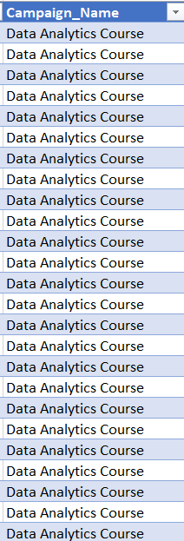
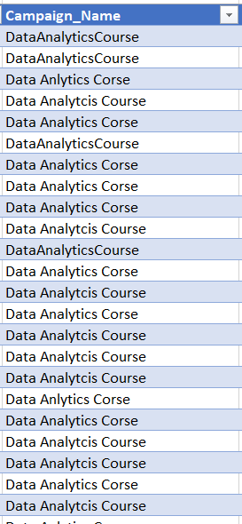

COLUMN 3 — Clicks
Problem Identified:
No structural issues, only needed numeric validation.
Action Taken:
Converted to numeric and checked for blanks.
Steps Followed:
- Validated numeric column
- Filled missing values (if any) using median
Formula Used:
=IF(C2="", MEDIAN($C:$C), C2)

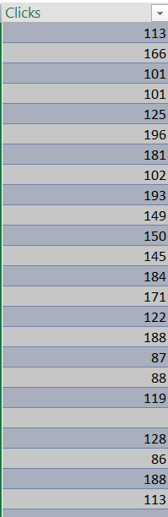
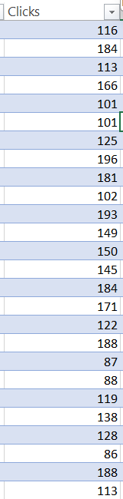
Original data: Standardized:

COLUMN 4 — Impressions
Problem Identified:
Column was clean but some rows had small inconsistencies.
Action Taken:
Cleaned data and filled blanks.
Steps Followed:
- Converted all values to number
- Filled missing values using median
- Ensured no negative values
Formula Used:
=IF(D2="", MEDIAN($D:$D), D2)

Original data: Standardized:
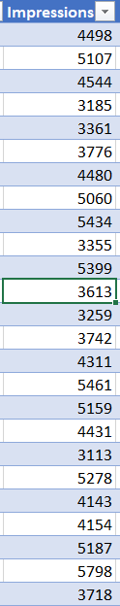
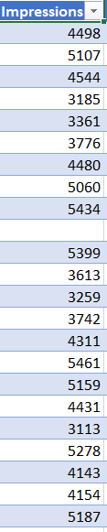

COLUMN 5 — Cost
Problem Identified:
Currency symbols ($) and blanks created errors.
Action Taken:
Removed symbols, converted to number, filled missing values.
Steps Followed:
- Removed “$” using SUBSTITUTE
- Converted text to number
- Replaced blanks using median stored in helper cell
Formula Used:
=IF(F2="", $Z$1, VALUE(SUBSTITUTE(F2,"$","")))

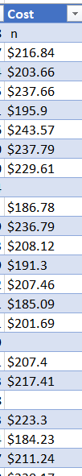
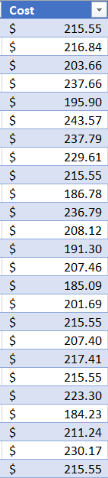
Original data: Standardized:

COLUMN 6 — Leads
Problem Identified:
Few missing values.
Action Taken:
Filled missing values using average/median.
Steps Followed:
- Validated numeric data
- Replaced blanks with average value
Formula Used:
=IF(G2="", AVERAGE($G:$G), G2)

Original data: Standardized:
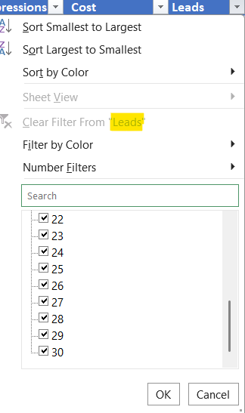
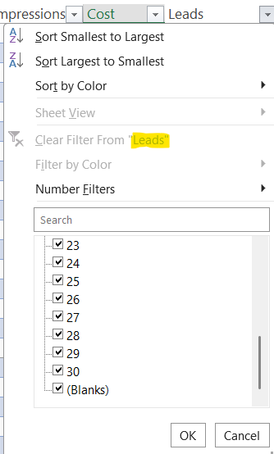

COLUMN 7 — Conversions
Problem Identified:
Missing values impacted further calculations.
Action Taken:
Filled missing values using average.
Steps Followed:
- Checked missing rows
- Applied average replacement formula
Formula Used:
=IF(H2="", AVERAGE($H:$H), H2)

Original data: Standardized:
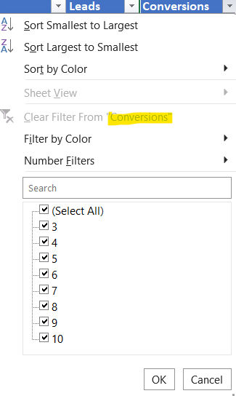
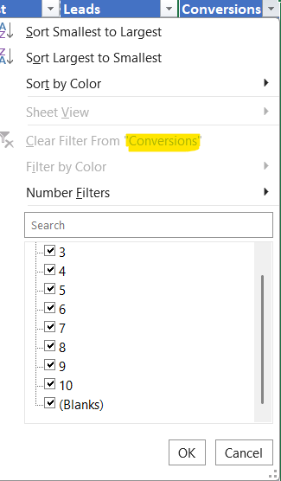

COLUMN 8 — Conversion Rate
Problem Identified:
Incorrect or blank conversion percentages.
Action Taken:
Recalculated Conversion Rate based on Clicks & Conversions.
Steps Followed:
- Used formula = Conversions / Clicks
- Applied percentage formatting
- Fixed zeros
Formula Used:
=IF(C2=0,0, H2/C2)

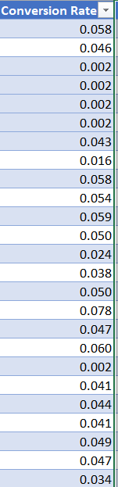
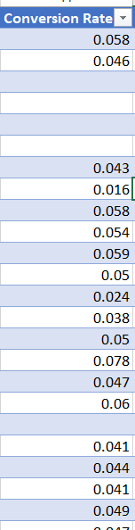
Original data: Standardized:

COLUMN 9 — Sale_Amount
Problem Identified:
Missing values and formatting issues.
Action Taken:
Filled blanks using median and cleaned numeric values.
Steps Followed:
- Converted values to number
- Filled missing entries
- Ensured positive values
Formula Used:
=IF(I2="", MEDIAN($I:$I), I2)

Original data: Standardized:
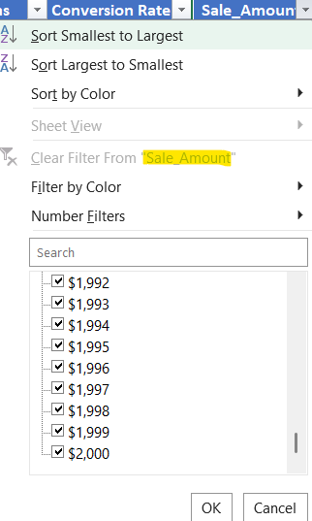
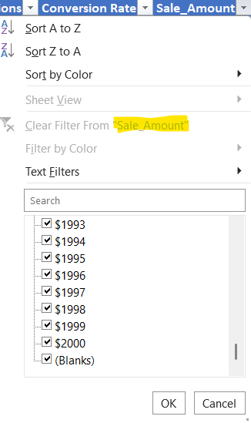

COLUMN 10 — Ad_Date
Problem Identified:
Some dates not recognized due to text format.
Action Taken:
Converted text to proper date type.
Steps Followed:
- Used DATEVALUE()
- Applied date formatting
- Removed blanks
Formula Used:
=IFERROR(DATEVALUE(J2), J2)

COLUMN 11 — Location
Problem Identified:
Unnecessary spaces and inconsistent names.
Action Taken:
Cleaned up using TRIM.
Steps Followed:
- Removed spaces
- Standardized city names
Formula Used:
=TRIM(K2)

Original data: Standardized:
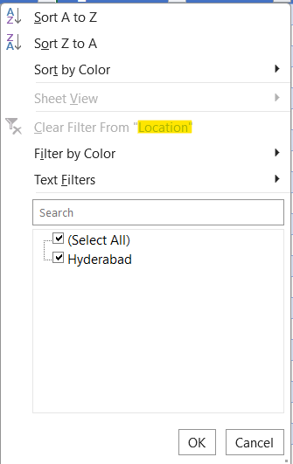
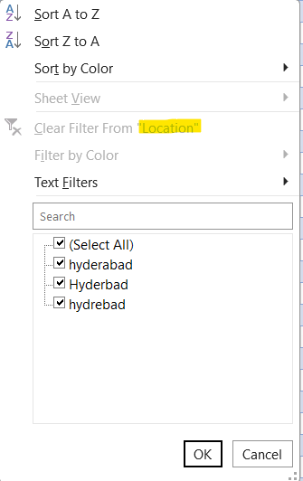

COLUMN 12 — Device
Problem Identified:
Capitalization inconsistent.
Action Taken:
Standardized device names.
Steps Followed:
- Applied proper case
- Removed trailing spaces
Formula Used:
=PROPER(TRIM(L2))

Original data Standardized:
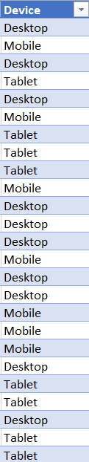
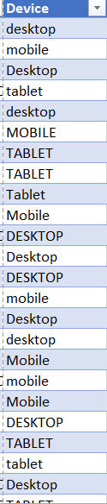

COLUMN 13 — Keyword
Problem Identified:
Different variations of same keyword (spacing issues).
Action Taken:
Standardized keywords.
Steps Followed:
- TRIM
- PROPER
- Checked duplicates
Formula Used:
=PROPER(TRIM(M2))

Original data: Standardized:
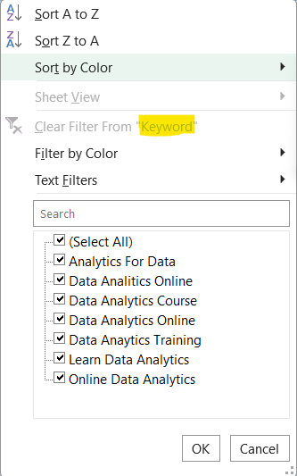
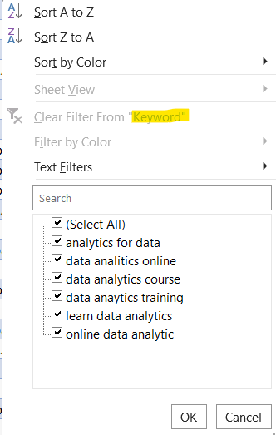

POWER-BI VISUALISATION/DASHBOARD

1. Action Taken

a) Data Import & Modeling
- Imported the cleaned Excel dataset into Power BI.
- Ensured correct data types (Date, Whole Number, Currency).
- Built proper relationships between tables (if any).

b) Created Necessary Measures
- Developed DAX measures such as:
  - Sum of Total Clicks
  - Sum of Total Cost
  - Sum of Total Impressions
  - Sum of Sale Amount
  - Other aggregations for visualizations.

c) Built Interactive Visuals
- Designed KPIs, donut charts, bar charts, treemap, and trend visuals.
- Added slicers (Ad_Date, Keywords, Device) for filtering.
- Formatted visuals with consistent colors, shadows, titles, and spacing.

d) Enhanced User Experience
- Structured dashboard into clear sections:
  - Performance KPIs
  - Keyword Analysis
  - Device Analysis
  - Daily Sales Trend
  - Cost Comparison
- Ensured layout clarity & removed empty white spaces.

2. Steps Followed

Step 1: Load Data
Home → Get Data → Excel → Select file → Load.

Step 2: Data Cleaning (in Power BI)
- Checked column data types.
- Removed unnecessary fields.
- Renamed columns for clarity.

Step 3: Create Measures
Modeling → New Measure
Examples:
Total Clicks = SUM(Table[Total Clicks])
Total Cost = SUM(Table[Total Cost])
Total Impressions = SUM(Table[Total Impressions])
Sale Amount = SUM(Table[Sale Amount])
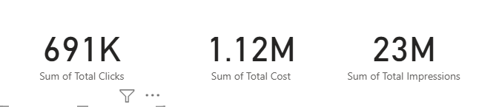

Step 4: Add Visuals
- KPI cards for Totals
- Treemap for Daily Sale Amount
- Bar Chart for Sum of Cost by Keywords
- Waterfall Chart for Sale Amount by Keywords
- Donut Chart for Conversions by Device
- Pie Chart for Sale Amount by Conversions

Step 5: Add Slicers
Insert → Slicer
Used fields:
- Ad_Date
- Keywords
- Device
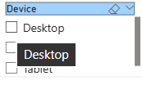
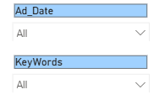

Step 6: Format the Dashboard
- Adjusted colors
- Aligned visuals using Snap to Grid
- Added readable titles
- Removed white empty areas

3. What Each Visual Conveys
- KPI Cards (Clicks, Cost, Impressions, Sale Amount)
Shows overall marketing performance at a glance.
- Treemap – Daily Sale Amount
Shows which days are performing well vs low.
Identifies daily fluctuations in sales.
- Waterfall – Sale Amount by Keywords
Shows how each keyword increases/decreases total sale amount.
- Donut Chart – Conversions by Device
Shows which device (Desktop / Mobile / Tablet) brings the most conversions.
- Bar Chart – Cost by Keywords
Shows which keyword consumes more ad spend.
- Pie Chart – Sale Amount by Conversions
Compares sale amount across different conversion groups.
- Slicers
Allow users to filter dashboard by:
- Date
- Keyword
- Device type

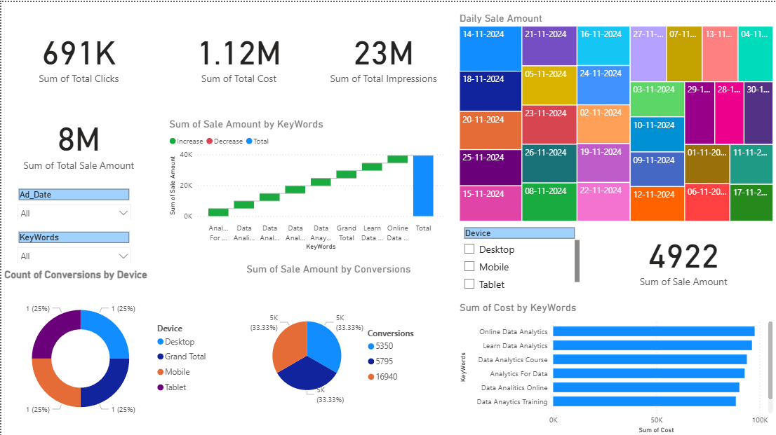
DASHBOARD

Final Insights

Key Insights from the Dashboard
- Total Clicks = 691K, showing strong engagement.
- Total Cost = 1.12M, indicating high marketing investment.
- Total Impressions = 23M, meaning high visibility across platforms.
- Total Sale Amount = 8M, showing good revenue generation.
- Device analysis shows Desktop, Mobile & Tablet contribute evenly, each around 25% conversions.
- Certain keywords significantly increase sale amount, while a few decrease it (visible in waterfall chart).
- Daily sales trend highlights fluctuations, helping identify high-performing dates for running ads.
- Cost distribution shows which campaigns consume higher budgets.

Conclusion
The project successfully demonstrated the complete workflow of data cleaning, analysis, and visualization using both Excel and Power BI.
Through systematic cleaning techniques in Excel—such as handling missing values, standardizing columns, applying formulas, and converting ranges into structured tables—the dataset was prepared for accurate analysis.
Power BI further enhanced the insights by transforming the cleaned data into interactive dashboards, allowing dynamic filtering and deeper exploration of trends.
The visualizations clearly revealed patterns in clicks, cost, impressions, conversions, device usage, keyword performance, and daily sales behaviour.
Overall, this project strengthened practical skills in:
- Data preparation
- Analytical thinking
- Visualization design
- Insight extraction
The final dashboards provide a comprehensive understanding of business performance and support better decision-making for marketing and sales teams.

